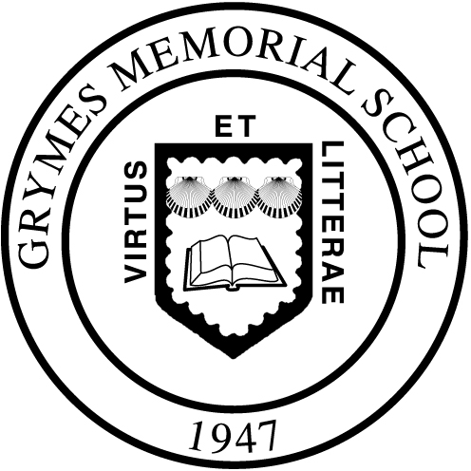
Your Personal Folder
Your Personal Folder is where you can get to all the files you’ve saved regardless of what computer you’re using in the school. Here are the steps when you want to access your Personal Folder to get to a file you’ve saved:
- From the “Start Menu”
- Select “My Computer”
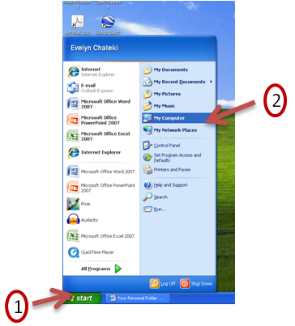
- Double Click on Network Drives – Grade<?> on ‘grymes-server1\public\students’ (S:)
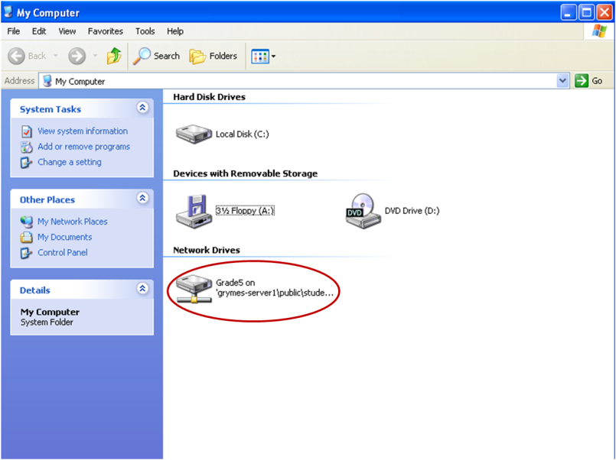
- Double Click on <Your Personal Folder>
- Double Click on the file you want to open. It will automatically start the appropriate application.

Saving a File to Your Personal Folder
Here are the steps when you want to save a file to your Personal Folder:
- From the application select “save” or “save as”
- Select “My Computer”
- Click on Network Drives – Grade<?> on ‘grymes-server1\public\students’ (S:)
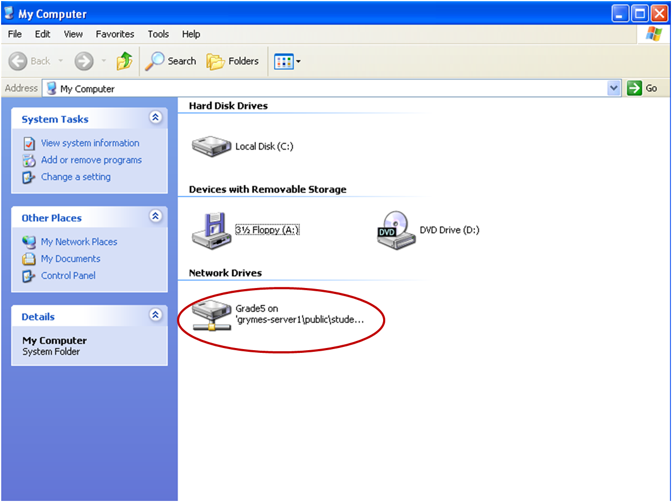
- Double Click on <Your Personal Folder>
- Give your file a name that will help you tell files apart
- Click on “Save”

